Chapter 1
INTRODUCTION TO DESIGN PROBLEM

1.2 Project Background
Outboard bearing is an outside bearing that holds a mandrel of a coil. It is called an outboard bearing because it gets moved when the mandrel needs to extract/insert. The current outboard bearing is taking more space than it should. The problem starts when the outboard bearing is opened, there is needed space taken by the outboard. The company wants to minimize the outboard bearing space, so they can occupy the left space with more equipment or leave for the employees to move freely. Figure 4 shows an outboard bearing support attached to the mandrel. The coil of steel would go through several processing steps on the slighting line machine before it got ready for use. The plate of steel would slide over the machine and they got all the waves out of it. After that the steel would be flatten and recoil it up around the mandrel. In figure 4 All what the outboard bearing does just helps to support the strip tension and holds the mandrel.
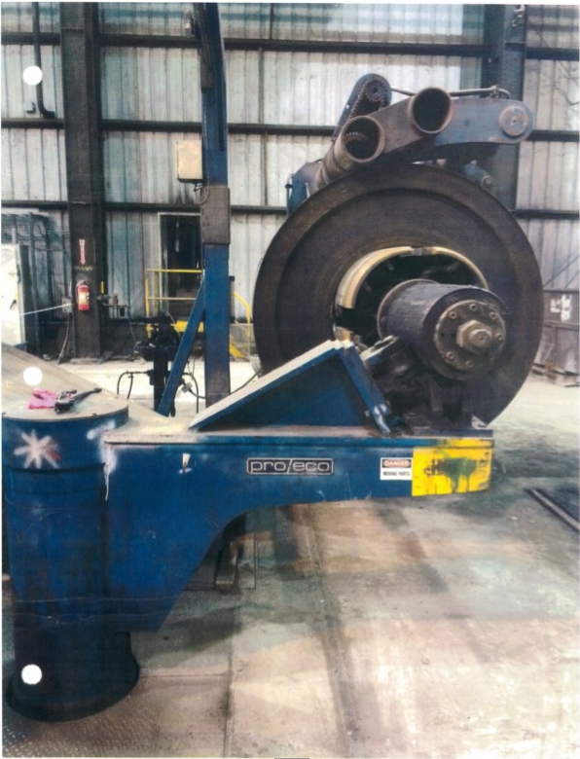
Figure 4. Small Outboard Bearing Support.
A new design will help the company to save more space around the coil. SES contacted some international designer company to look for a capable design. They found an Italian company that would be happy to show SES their design. As shown in Figure 5, the new design can extract/insert vertically, that will save more space around the coil.

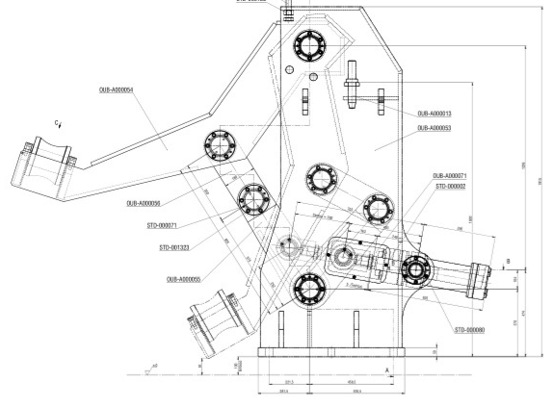
Figure 5. The Future Design.

1.3 Requirement and Specification

1.3.1 Initial Needs Statement

The SES proposed project is to redesign the current outboard bearing support which swings in and out of the slitting line machine. They are planning to replace the current design with a new one that has a supported arm moving vertically. The interchangeable movement in the new outboard bearing will ease the forklift traffic to unload the coil because of the less footprint. The new design was provided by the client and it should be modified to withstand the 80,000 lbm coil besides the 30,000 lbf strip tension. This process requires not only working on the force analyses in the entire mechanism, but also the failures points which will lead the design to fail. To modify the system appropriately with the high compressive load that acts on the roller bearing, it is significantly important to figure out all the reactions and failures in the model.

1.3.2 Customer Needs Statement
The assigned project begins in September of 2018 and is expected to be successfully completed no later than May of 2019. The senior student group met with chief mechanical engineer at SES on September 8, 2018 to discuss the important details and requirements of the project. During this meeting, SES provided a new outboard bearing support for their repertoire. The provided model was not designed for the proper weight, so it needs to be modified to withstand heavier coil. the required design can be seen in figure 6.
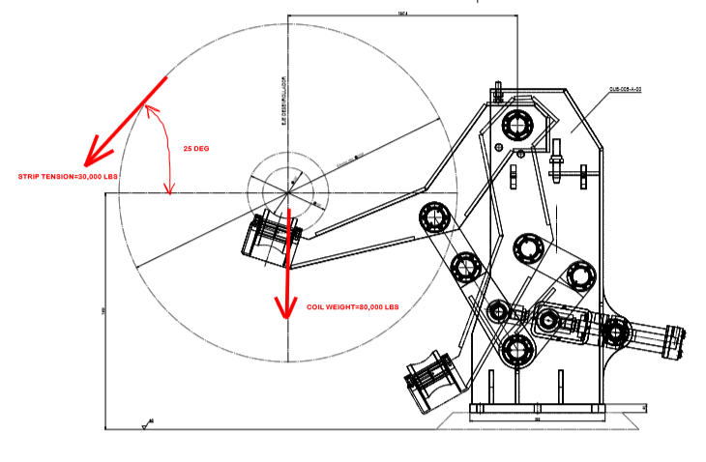
Figure 6. New SES Outboard Bearing Design with Applied Load.
The scope of the entire project is understood, and the customer needs were listed in the first meeting. The original customer needs require to develop the OBBS:

- Withstand heavy weight.
- Ability to hold high compressive load
- Imperial dimensions
- 3:1 Yield, 5:1 Ultimate Tensile strength
- Limited material selections
- Maximum hydraulic pressure of 1500 psi
- 3-D software package
- 40,000 hr minimum bearing life
- Safety

1.4 Revised Customer Needs and Weightings Statement
After the original customer needs were discussed and being revised into a table that indicates the customer needs and engineering characteristics, the company weighted each one of the customer needs scale from 1 to 5 which are the gradual ranks depended on the importance of each customer need. The engineering characteristics were developed based on the revised customer needs which involves more details that help to meet the requirements properly. Table 1 pictured each original and revised customer needs that corresponded to the associated engineering characteristics.

Table 1. Customer needs evaluation and engineering characteristics.
Customer Need | Refined Customer Needs | Engineering Characteristics
Drawing on computer | 3-D Software package | Variable Design
Convert design dimensions | Imperial dimensions | Standard part size
1500 psi max hydraulic pressure | 1500 maximum input pressure | Pressure
Increment of 0.25in of the plates | nominal imperial Sizes of plates | Standard plate sizes
Heavy coil | Withstand heavy weight | Weight
Moving Arm | Mandrel support arm clearance | Distance
Expense | Cost | Budget
High load | High load | Normal stress / Shear stress
Rotational Support | Bearing support | Materials
Safe | Safety | Meet OSHA standards

The revised customer needs were weighted by the client based on importance consideration of the company. The weights and the corresponding engineering characteristic are seen in Table 2. The weighting determination of the company shows that the design should withstand high load and weight are the most important while the cost is the least.

Table 2. Customer Needs Weighted
#
 | Customer Need | Customer weight
1 | 3-D Software Package | 5
2 | Imperial dimensions | 5
3 | 1500 maximum input pressure | 3
4 | Nominal imperial sizes of plates | 5
5 | Withstand heavy weight | 5
6 | Mandrel support arm clearance | 4
7 | Budget | 3
8 | High load | 5
9 | Bearing Support | 4
10 | Safety | 5

1.5 Assessment of Engineering Characteristics

Once the customer needs are weighted by the client, a matrix to relate the revised costumer needs and the engineering characteristics was created. That was used to increase the understanding of the project challenge and to list the target specification which will be mentioned in the next section. There are three different correlation values scaled as 1,3 and 9 which represent the strength of correlation rated by the highest to lowest value. Table 3 shows the matrix indicating the correlations and absolute scores that calculated by multiplying the correlation times the weighting. The absolute score helps the group to arrange the most significant engineering chart and least based on the height of the result.

Table 3. Importance of Customer Needs and Engineering Characteristics.
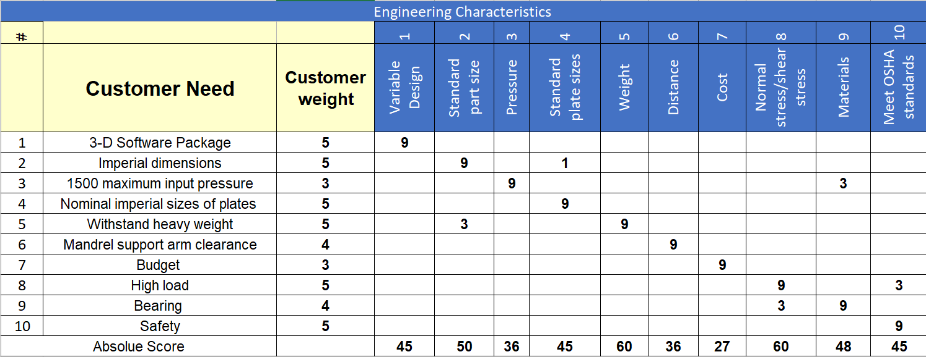

1.6 Project Statement

SES planned to replace their current outboard bearing support that swings in and out by a new one which will have a rotational motion in order to reduce the footprint. They provided a design which is valid only for lighter weight and must be redesigned to withstand heavier coils. Figure 7 pictured the transition between the current and the future design. The client stipulated certain conditions that must be completed in the project. One of the important needs is that the design must be capable the 80,000 lbm coil plus the 30,000 lbm strip tension. In addition, it is required to convert the dimensions unit from metric to imperial to build locally and to standardize the plate as nominal size. Figure 7 is a picture of the current and the new design.

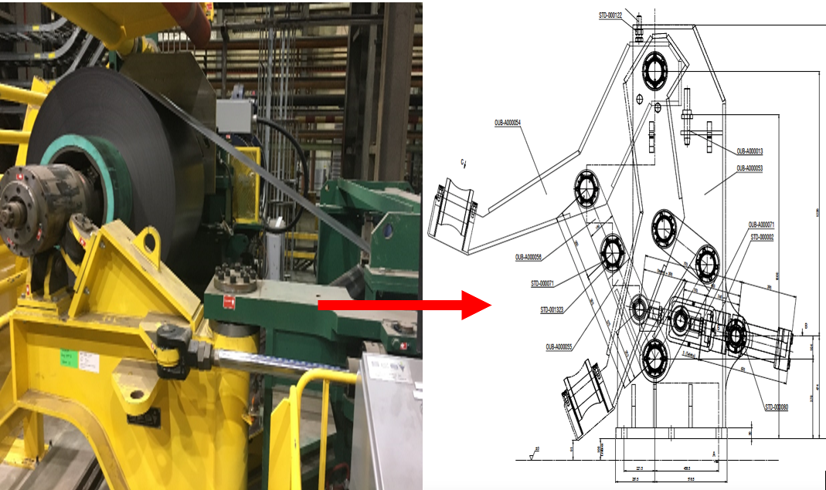
Figure 7. The Current and New Design.

Basically, the operating way and the design of each machine is totally different than the other. The current one designed as one solid part and its roller would keep rotates while the mandrel operated. On the other hand, the new one built as a few parts jointed together as a four bar mechanism.

1.6 Target Specifications

The obtained absolute scores are playing an important role in ranking the all ten engineering characteristics in order of importance which helped the team to create a target specification table. The created table delivered functional expectation to the group regarding the priority of each one engineering characteristics. It also allows the team to identify which ones are the most essential to overall success of the design. The target specification table containing each engineering characteristic were listed in order of the significance based on the highest of the score vale, and the following parameters: the unit, the marginal and the ideal value. Table 4 shows the list of target specifications indicating that stresses and weight are the most important, and cost has the least priority.

Table 4. Target Specification Table.
Need(s) | Eng. Characteristics | Importance | Unit | Marginal Value | Ideal Value
8,9 | stresses | 1 | Pass/Fail | Pass with no failure | Pass with lower stresses
5 | Weight | 1 | LBM | 97677 lb. | 100,000 lb.
2,5,9 | Standard part sizes | 2 | Inch | Metric | Imperial
3,9 | Materials | 3 | Pass/Fail | - | -
8,10 | Meet OSHA standards | 4 | FOS | Meets the required FS | Exceed the FS
2,4 | Standard plate sizes | 4 | Inch | Actual size | Nominal size
1 | Variable Design | 4 | Pass/Fail | - | -
3 | Pressure | 5 | Psi | 2000 Psi | 1500 Psi
6 | Distance | 5 | Inch | 6.5 in | 8 in
7 | Cost | 6 | $$ | 90,000 | ≥$86,000

1.6.1 Stresses

The most important engineering characteristic is the stresses in the due to the high load and bearings in the design. The main purpose of the design is to be modified to be capable support a mandrel that holds 30,000 lbm strip tension and the 80,000 lb coil weight. In this case, the reaction force that is attributed to support is very high which will lead to face high amount of different stresses such as contact, normal, shear, and bearing stress. Moreover, the bearing life should be taken under consideration as 40,000 hr is minimum bearing life.

1.6.2 weight

The weight is one of the most important engineering characteristics which might cause failure in the design if it is not taken under consideration. It is significant to design the proposed project to withstand heavy weight. The marginal value of the weight was expected to be 97,677 lbm which is total weight. The team made a decision to target that total weight as the marginal and the ideal value to be 100,000 lbm in order to design the model more safely.

1.6.3 Standard part size

Silco which is an Italian company that the original designer of provided design allowed to share the design with SES to be built locally in the US. The entire design was established in metric units which is an international unit. It is required to convert the dimensions to IS units of measurements which is the ideal value in order to build in the states easily.

1.6.4 Materials

limited selections of the material for the plates’ fabrications and pins, as well as the bearings purchases were required by the company. The client wants to design the plates with carbon steel A572 Grade 50 materials and one of the following for pins: AISI 1045, AISI 4140 or AISI 1018 which is the hardest comparing to the other two. SKN and NTN are the two purchases sites were selected by the client for the bearings.

1.6.5 Meet OSHA Standards

The Occupational Safety and Health Administration (OSHA) which a mission is to ensure that employees work in safe environment by sitting and enforcing standards. The safe design delivers safe working environment that keeps the operators life out of occupational death and injury. It is highly important to deliver a safe design to the company to avoid dangers.

1.6.6 Standard plate sizes

As mentioned above the design will be build locally, so the client preferred the plates should be standardized with nominal sizes.

1.6.7 Variable Design

3-D mechanical drawing and force analysis by using ANSYS must be completed in order to double check the hand calculations by matching them with the obtaining FEA result. SolidWorks will be used for the drawing to continually process the design ingredients. It also gives better understating the complex geometry and supports the hand calculations by picking the dimensions of any cross-sectional areas.

1.6.8 Pressure

The hydraulic cylinder usually used in mobile application. It will be attached to the design to support the boom arm motion by creating mechanical pressurized force in a linear motion. The pressure input of the hydraulic was planed to be 2,000 psi as a marginal value then will be 1,500 psi as maximum in the final draft of the project.
1.6.9 Distance

The clearance distance between the coil and the arm while unloading position is ranged between 6” to 8”. The goal is to design it with 8” away from the coil which will reduce the footprint to ease the forklift traffic.

1.6.10 Cost

A budget of $86,000 is estimated to sponsor the entire project. The team will reach the marginal value first which is $100,000, then working on reduce the price as much as possible.

1.7 Group Allocation

The new provided design should be replaced instead of the current one. The operations have harder time when they try to unload the coil out of the machine because of the swings OBBS which takes more footprint. The company proposed this project to change the mobility of the support arm from horizontal to vertical rotation.

1.7.2 Recourses Allocations

Resource allocation was split by university furnished items and client furnished items. The university furnished software (Computer Aided Design and Finite Element Analysis) for use of the project. This included, but was not limited to, SolidWorks, ANSYS, and Simulation Mechanical. In addition, the client provided hand calculations filed in PDF that containing the force analysis, bearing selections for their current design.

1.8 Budget

The preliminary budget is detailed in Table 8 given by SES. The budget considered the costs associated with design materials and labor. The materials costs changed as the design developed or beefed up further. The client expected that the total cost to be 86,000 USD. As long as the development of the project worth more money, the client is well to sponsor with higher budget. Table 8 highlights the cost of each part of the entire assembly as well as the labor engineering hour.

Chapter 2
PRIMARY ANALYSIS TECHNIQUE

2.1 Design Evolution

The hydraulic cylinder controls the swinging motion of the current design, which is constructed from stainless steel. It was planned to be developed in several aspects especially in its mobility. The current design was a model of unchangeable design, so SES provided a replacement one that was required to be analyzed. They saw a need for analytical results which proves the capability of it to withstand the required load. The group went over different processes to move forward to the analysis of the evolution which started with identifying the problem, understanding the client’s requirements and analyzing the future design to have a better idea about how much stress effects the design.

2.2 Design Features

The new model which was designed as a four-bar mechanism assembles with two linkages, a frame and a rotating arm. The lower linkage was used as an input link to drive the coupler which was the upper link, and the rotating arm was assumed to be the follower. There was a hydraulic cylinder attached to the assembly and it was mounted to the driver link which was pinned to the frame by rotational fasteners in order to transform the linear motion that exerted by the cylinder to rotational motion. The driver rotated about the z-axis in angle ranged from 20 to 125 degrees which reaches the dead point. The interesting technique in designing the machine was that when the mechanism reached the dead-point the forces which act on the upper and lower linkages become zero due to the static equilibrium. When the forces were zero then the hydraulic cylinder is not going to exert more force to react against it and that prevent jamming to occur by not pushing the links further than the dead-point. Figure 8 indicating the components of the model and pictured the motion of the arm.

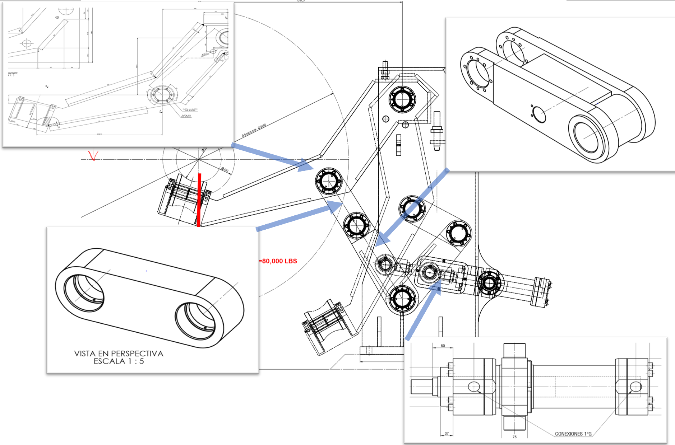
Figure 8. Shows the Component of the Assembly

2.3 Design Aspects

As mentioned previously, the outboard bearing was modeled with a rotating arm to reduce the footprint and make it easier for unloading the coil. The group considered that the design was consists of various aspect which were evaluated to be positive and negative aspects. Consideration of those aspects was evaluated based on several contributing factors such as complexity of geometry, cost, construction, analysis, and 3D drawing. For instance, the geometry of the design was modeled in complex way and that might effect on the accuracy on the stresses calculation; in the other hand, it gave the design unique and shorter shape which make it more proper with our purpose.

2.4 Analysis Technique:
While processing the design, various main assumptions were taken under the group consideration. There are different types of stresses which play an important role in causing deformation in the machine such as contact, normal, bending, shear and bearing stress. These stresses reacted due to the load and strip tension exerted from the mandrel. Each one of these assumptions would be explained deeply and how it would be analyzed in separate section.

2.4.1: Contact stress:

There was contact stress accruing due to the transmitted force between body of the roller bearing and the mandrel. That contact should be taken into account because it would cause deformation in the body depending on the magnitude of the contact stress. In this case, the outboard bearing was constructed to touch the mandrel by attaching line contact of the mandrel to large contact area of the roller which means the Hertz technique led to end up with inaccurate result. The groove shape of the roller and the attachment of the cylindrical shape of the mandrel makes the situation odd to be solved by hand, so the group members decided to solve that issue by using the closer case to the design situation of Hertz technique and FEA to compare the results and see which one was the worst case or made more sense. Figure 9 shows the different cases of contact stress.

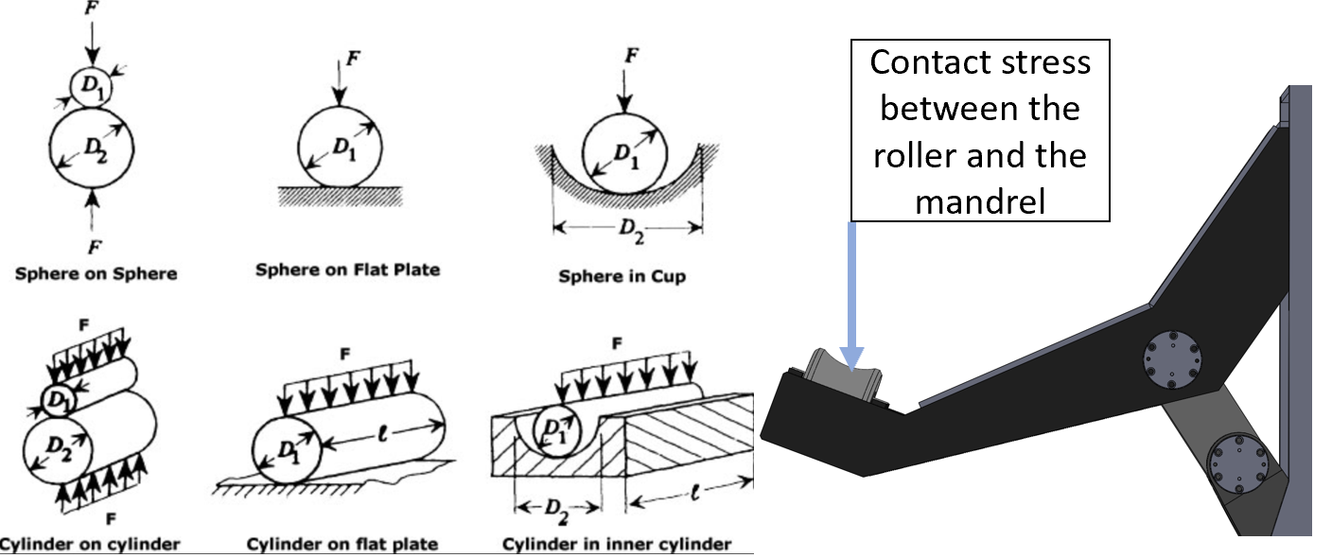
Figure 9. Cases of contact Stress. [Hertzian Contact Stress, 2013-2019]

2.4.2 Normal stress:

As known, the normal stress occurs when the member is loaded by an axial force. When the arm stands in the raising position, the load would be transmitted to the upper and lower linkages which are two force members. These two linkages are straight from pin to pin and lead the force to act in the axial axis. As long as the load is passing through the centroid of the cross-sectional area then it would cause normal stress. In that case, the group assumed that the force is uniformly distributed over the cross sectional. Figure 10 is a picture of how the force uniformly distributes in tension.

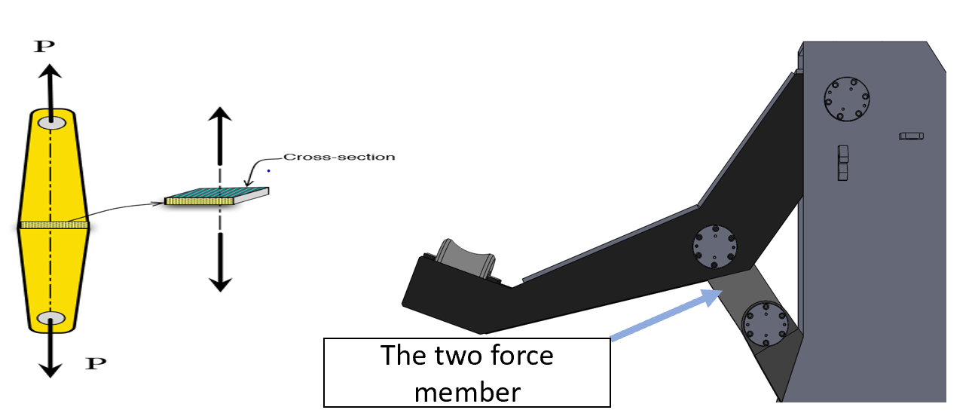
Figure 10. Force Uniformly Distributed in Tension.

2.4.3 Bending and Shear Stress:

Both bending and shear stress would occur due to the experienced load that exerted from the mandrel. There were two types of bending stresses that the model might face such as the pure bending and maximum bending moment. The one which was more likely to happen in our case is the maximum bending moment. This took a place about the z-axis in the rotating arm and the frame of the entire design. The assumption of that was based on the applied force which would cause the structure to bend. During these points of the maximum bending, shear force always is zero. However, in other points of the design there would be shear forces and the group would calculate the failures due to the shear stress, which depends on the highest amount of shear value. In addition, the shear stresses would affect the fasteners as single shears because the load applied in one plane that would result the fasteners being cut into two pieces only. Figure 11 shows the applied forces to the single plate that is connected by a bolt.

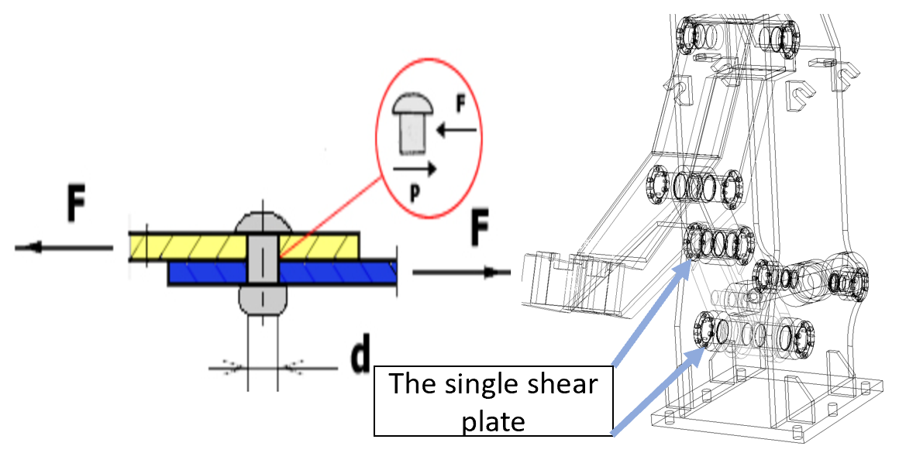
Figure 11. Applied Forces to the Single Plate.

2.4.4 Bearing Stress:

Bearing stress would occurs in the holes of each part in the assembly because of the contact pressure between the separate bodies. Also, there was a chance of facing very high tear-out stress which would cause deformation or maybe a failure in the design. The bearing life was assumed to be never reached due to the small amount of constant RPM and the application was not constantly rotating, so there would not be in issue with that. However, the failure mode of the application might happened with static vibration and impact loading.

2.5 Design Modification:

Based on the previous analysis, the design would be sized and standardized with the proper load. There were set of needs required by the clients as mentioned in the previous chapter. Modifying the design and sizing the hydraulic cylinder were ones of the important needs; therefore, the group focused in these two and made some primary assumptions.

2.5.1 Plates Standardization:

As known the design was modeled to withstand lighter weight, so there was a small chance to size it down in order to lower the cost over fabrication. The design should standardized in nominal size which means in increment or decrement of 0.25 inch. The group members have done an initial analysis just to see if the materials of the plate would withstand the proper load if it sized down or not. Based on the obtained results, the design might hold the mandrel if it builds with a material that has at least yield strength of 50,000 psi. However, that would increase the risk of failure in the pins and shaft because of the small diameter size which would decrease the cross-sectional area.

2.5.2 Hydraulic Cylinder Sizing:

The hydraulic cylinder was maximized with an input of 1500 psi which was assumed to be more than enough power to push the rotating arm. There were several types of hydraulic and the best choice for the design purpose was the double mounting hydraulic cylinder. Because of the way that the design modeled, double mounting hydraulic could be attached to two ends in the design. The cylinder would be sized based on the weight of the design itself because of the arm in the raised position makes the linkage is straight from pin to pin to pin in the raised position, so the force goes straight through the linkage and did not put force into the cylinder. Figure below shows when the outboard bearing was operating under load, the cylinder isn’t seeing any load. The rod end was adjustable, so it could adjust the cylinder during shop assembly to make sure in the raised position the linkage is straight.

CHAPTER 3
PRIMARY DESIGN ANALYSIS

3.1 Analysis Techniques:
The new design of Outboard bearing model was analyzed using analytical hand calculations and further verified with finite element (FE) analysis using Ansys software. Assumptions used in the design and analysis are also discussed in this section.

3.1.1 Design calculations and analysis:
The following parts were analyzed using analytical calculations and with FE analysis and stress values were reported for each of them: Arm, Frame, Upper linkage, Lower linkage, Roller’s shaft, and the plain roller. Von mises theory of failure was used to evaluate the design as all the plates are made of steel A570 G50. The failure was obtained either based on yield or ultimate strength depending on which one of the allowable stress values is higher. The client required that the allowable stress to be 3 and 5 based on yield and ultimate respectively. In addition, the allowable shear and bearing can be calculated by multiplying the allowable value by 0.577 and 1.25 respectively. All the hand calculation was detailed in the appendix E.

3.1.2 Analytical Assumptions:
Some of the assumptions were applied to the design in order to avoid any failures to occurs. One of the main assumptions that the group made was assuming the arm to be a rigid body instead of various components in order to obtain the reaction forces. There was also an issue with calculating the contact stress between the mandrel and plain roller. Based on the Hertzain’s roles for the contact stresses, there was no case provided that match the faced situation; therefore, Ansys software was used to get more accurate result. The Finite Element Analysis was performed in Ansys with very small meshing size which was enough to capture the stiffness of each component for more better result.

3.2 Determination of failure points
Analytical hand calculations were done to determine the possible failure points in the worst case location of each component. The result of the hand calculations might not be as accurate as the software due to some elements in each component which cannot be calculated by hand. For example, the rotating arm was analyzed by hand and there was no failure in it but when it was analyzed in the software, the group found a failure in one of the elements which has a size of 0.5”. Each one of the components was analyzed separately and it will be detailing in the next sub sections.

3.2.1 Mandrel analysis:
It was not required to complete any analysis for the mandrel, but the group should figure out the reaction forces acting on it to know what was the amount of load would act on the model. There were 3 different bearing reactions in the mandrel, and it holds 80,000 Ib of coil. In that case, the group faced indeterminate forces which was not match with any case in the stress and strain analysis and machine design books. The most accurate way to figure out that load was by using Ansys software. It was determined by applying the distributed load on the mandrel in the Ansys as it is statically indeterminate problem. The reaction force in the mandrel was found to be 33376 lbf in the Y direction as shown in Figure 3.1.
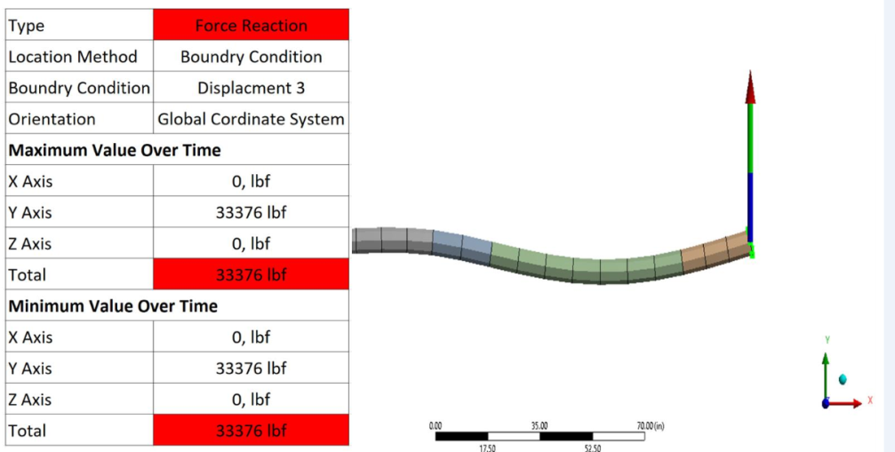
Figure 3. 1: Ansys result of targeted bearing reaction.

3.2.2 Plain Roller:
The mandrel was attached to the plain roller and it moved fourth and back in total distance of 12”. As long as the mandrel moved fourth and back, it forced the plain roller to rotate. It was assumed that the roller is not constantly rotating but only 22% of its area would be under the rotation. This assumption gave a hint that the maximum bearing life will never be reached because the roller did not keep rotating. The roller has a diameter of 8.66”, so the surface area was calculated to be 27.3 in². From there, the area that rotating can be found by divided half the distance which is 6” by the surface area. Figure 3.2 picturing when the 6” of the mandrel pass over the roller. In addition, the baring stress was easily determined by dividing the acting load by the obtained bearing area to be 1070 psi.
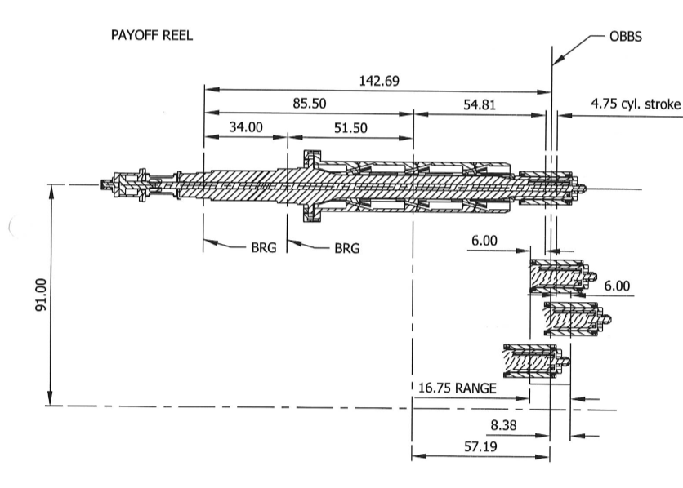
Figure 3. 2: 2D drawing of the mandrel and the location of the OBS.

3.2.3 Rotating Arm:
The arm was assumed to be a rigid body and in order to find the reaction forces acting at point A and B. The unknown forces were determined statically in equilibrium by assuming the moment at point B. The results of the reaction forces at point A and B were found to be 91,467 Ibf and 58091 Ibf respectively. From there, the maximum stress of the arm can be calculated by finding the location point of worst case stress which will be in this case in the middle pin. The maximum bending stress was found to be 9341 psi while the shear stress was 2617 psi. Figure 3.3 detailing the dimensions between the reaction forces and the direction of them as well.
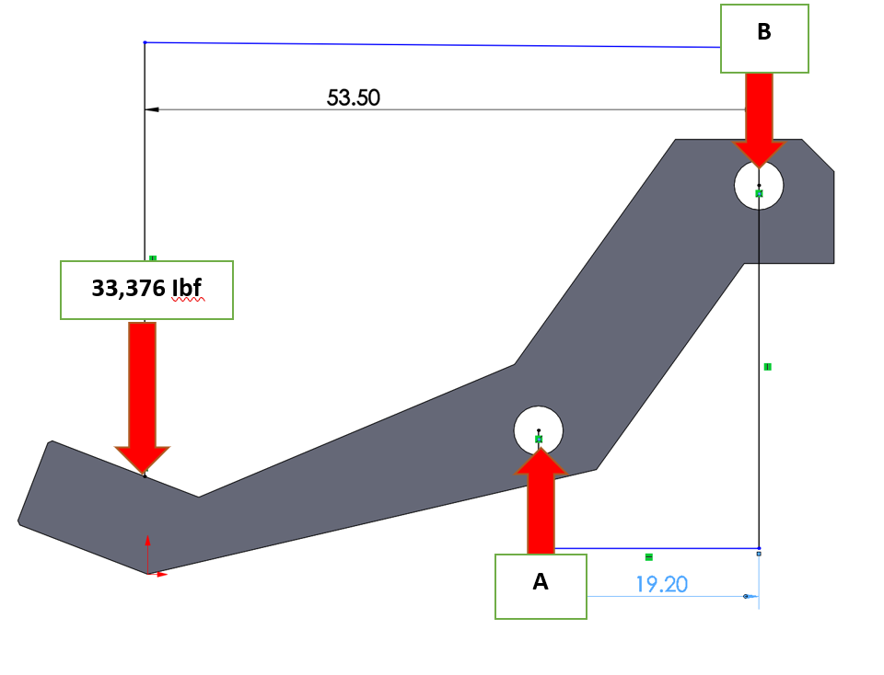
Figure 3. 3: Free body diagram of the rotating arm.

3.3.4 Upper linkage:
The upper linkage was jointed to the middle pin of the rotating arm and the amount of load 91,467 Ibf was applied due to the reaction force of the linkage itself. In the raising position the linkage which is a two force member was orientated in 32º from the positive y-axis. When the linkage orientated, a resultant force of 111,660 Ibf was acted along the natural x axis of it which caused only a normal stress. The cross-sectional area of the linkage is large enough to withstand that load, but it might cause a failure due to the tear out stress in the holes. The normal stress result was 3262 psi and the tear out stress was 9710 psi. Figure 3.4 shows the rising position of the linkage and the direction of the forces. Bearing stress was applied to the component due to the contact pressure between it and the pin. It was found to be 4855 psi.

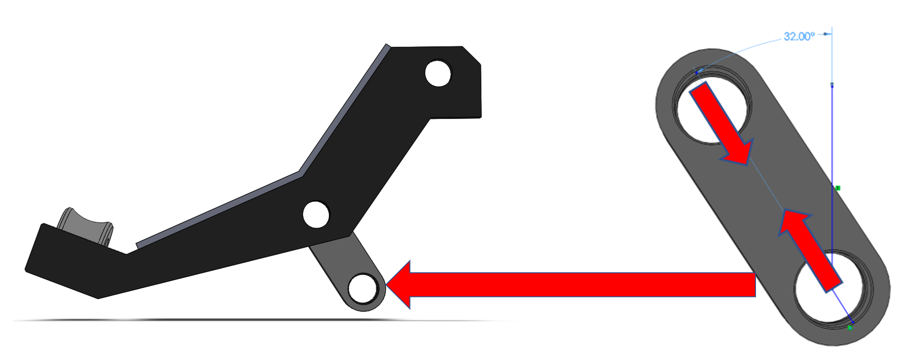
Figure 3. 4: The upper linkage in raising position with forces directions.

3.2.5 Lower linkage:
The lower linkage is a component that jointed to the upper linkage and mounted to the hydraulic cylinder. The motion of the rotating arm was controlled via this component by the pushing and retracting of the hydraulic cylinder of it. It was assumed that the linkage was statically fixed in the raising position in order to find the maximum reaction forces acting on it. The highest amount of load in the component was acting in the middle pin which is pinned with the tie rod of the cylinder. Figure 3.5 shows the rising position and the direction of the forces in the linkage. The amount of the highest load was obtained to be 220,219 Ibf.

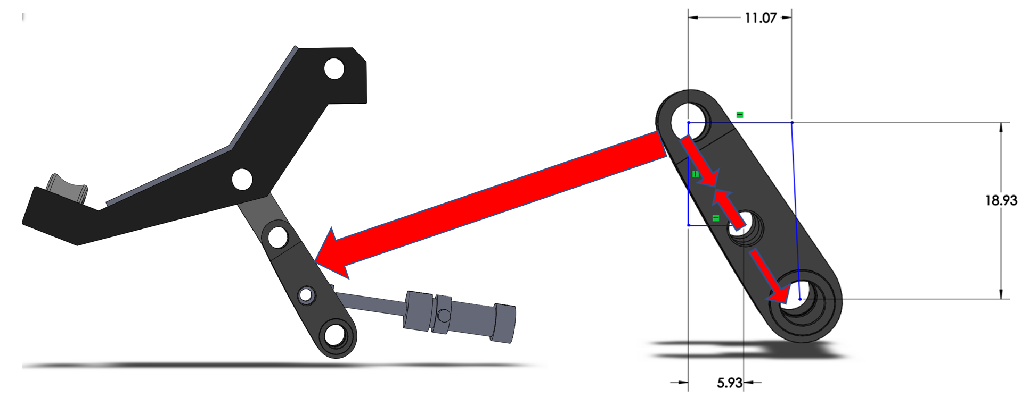
Figure 3. 5: Free body diagram of the lower linkage.

3.2.6 Fasteners:
The pins effected by a single shear because only one plane that would result in the fastener being cut into two pieces. All the pins have the same cross-sectional area size, so the stresses result was found only at point of the highest amount of load which was acted in the middle pin of the lower linkage. The shear stress was found to be 8470 psi which was lower than the allowable shear stress 12117 psi. Figure 3.6 shows the modeled pins for the design.

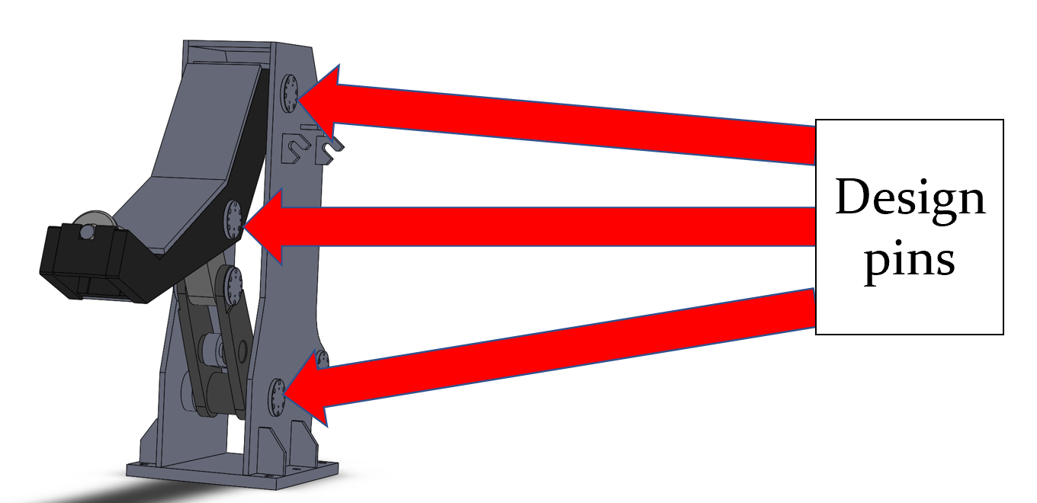
Figure 3. 6: The design pins.

3.2.7 Roller’s Shaft:
The shaft of the plain roller was built from 1045 Steel which has higher ability to withstand higher load. The used martials can hold up to 21,000 psi of stress. The shaft remained fixed while the roller rotated, so the group exclude the fatigue failures to occurs in this case. The maximum stress was calculated by multiplying the nominal stress by the stress concentration factor which was 2.25. Also, the nominal stress was determined by finding the centroid divided moment of inertia and multiplied by the maximum moment. The result of maximum stress was found to be 29407 psi which is very high.

3.3 Hydraulic cylinder sizing:
The hydraulic cylinder was sized based on the weight of the rotating arm and the two linkages. The group ignored the weight of the frame in sizing the hydraulic because it was focusing to control only the mentioned parts. The total weight was obtained from SolidWorks to be about 250 Ib-m. “Mill type” hydraulic was selected from Parker website to be a 5.5” bore diameter and that was the minimum size that withstand the proper weight. Based on the provided parameter in the website, the rod diameter and the tie rod were selected. The maximum pressure input was maximized by the client to be no higher than 1500 psi, so that led the cylinder to exert an amount of force of 30,000 Ibf. It was calculated by multiplying the pressure input by the cross-sectional area. Figure 3.7 is a picture of the selected hydraulic cylinder. In Appendix E, there are more details about the sizing selections of the cylinder. [Parker, n.d].
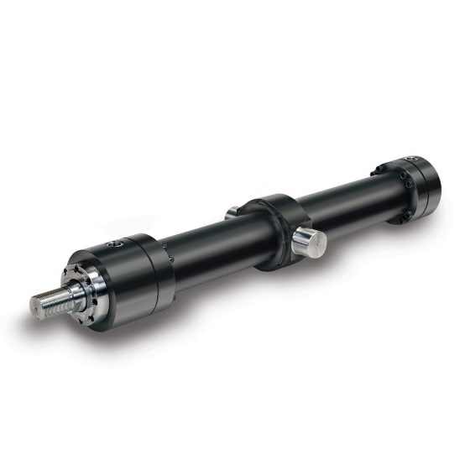
Figure 3. 7: Mill type hydraulic cylinder.

3.4 FEA Results:
Finite element analysis was carried out using Ansys software to determine the stresses in the various parts. The below sub-sections describe the details of the analysis of each component.

3.4.1 Rotating Arm:
While uploading the rotating arm into the software, some boundary conditions were applied to it which lead to more unique solutions. The arm was holding a load of 33,376 Ib-f which was reacted against the bearing support in the mandrel. The arm is freely move up and down for the loading and unloading position which will be about 7” away from the coil. The arm analysis was carried out by the remote displacement constraints at the point’s “B” and “C” with free rotation about the z-axis as shown in figure 3.8. Also, there was a load of 33376 lbf was applied at the point “A”.

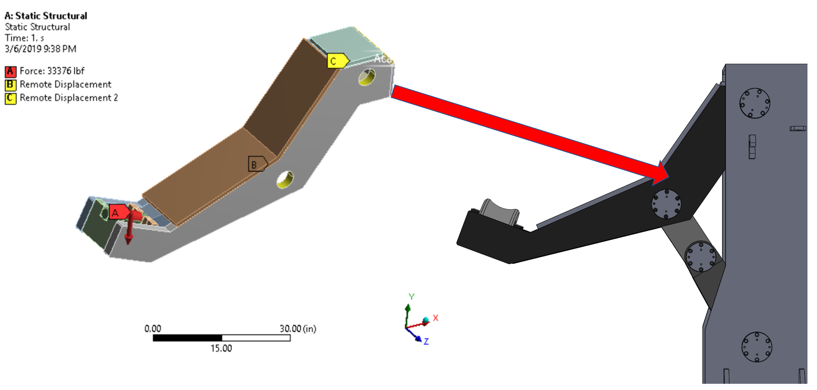
Figure 3. 8: Loads & boundary conditions setup.

The von Mises stress contour is shown in the Figure 3.9. The maximum value of the equivalent stress in the arm was found to be 21000 psi at the fillet location of the plate which means the result exceeds the allowable stress at that point.

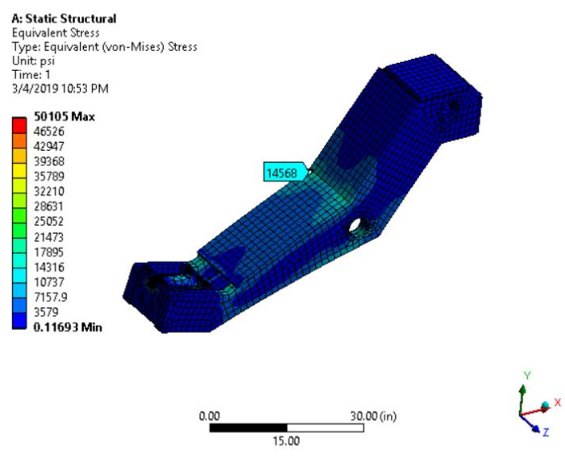
Figure 3. 9: Rotating Arm FEA result.

3.4.2 Frame analysis:
The frame has the largest cross-sectional area comparing to the other components and the lowest amount of loads. It was obvious that there was no failure in the frame but for more verification, it was brought into the software. The frame is a fixed component and it has a force that acting in the x-axis exerted by the hydraulic cylinder. Because of that, that force can be controlled if there was a failure based on the hydraulic input pressure and the cross-sectional area. There was a fixed support applied to the base of the frame at point B while the reaction forces those obtained by hand calculation were applied to the pin holes. The model was carried out by forces directed upward at points A and C of 89000 lbf and 58100 lbf respectively as shown in Figure 3.10. In the other hand the force that exerted by the cylinder was obtained to be 30,000 Ibf at point D.

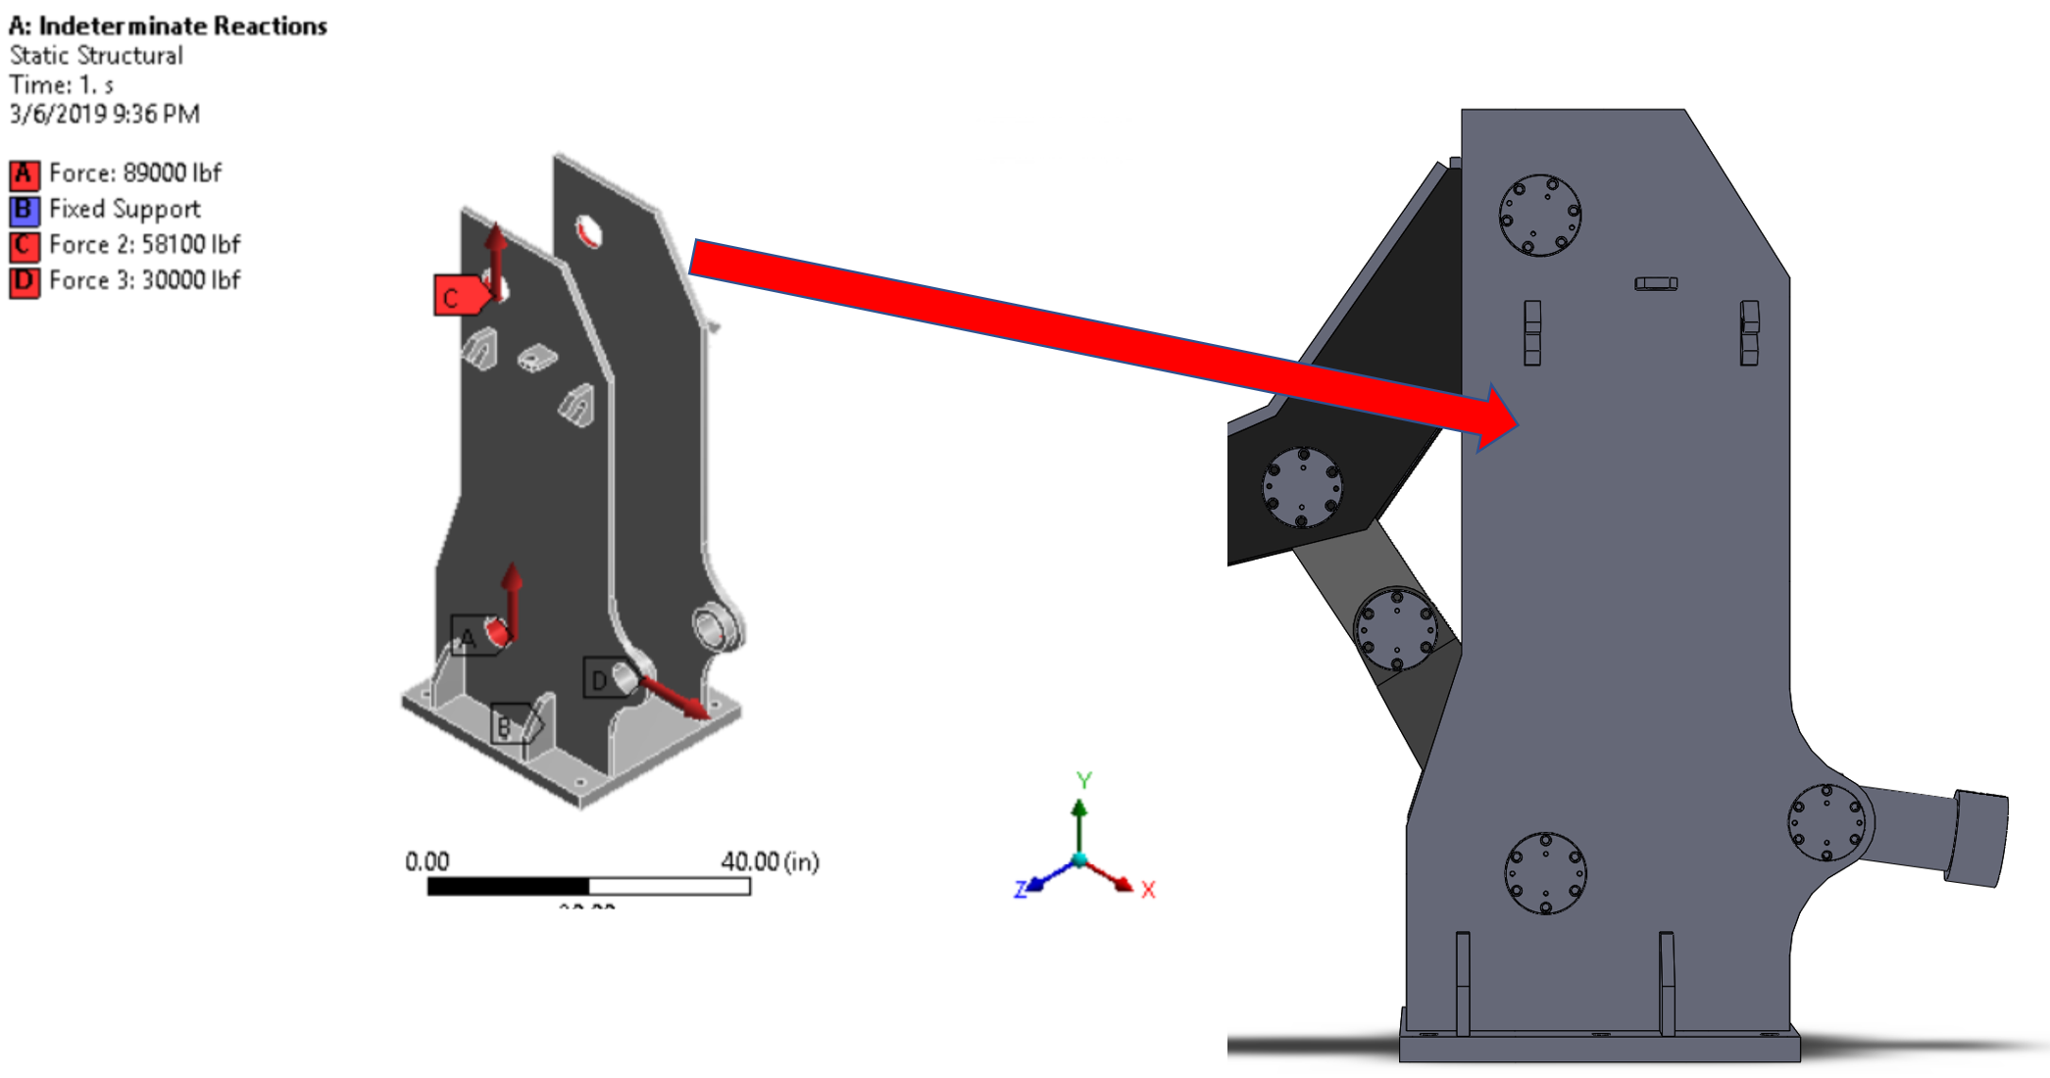
Figure 3. 10: Loads & boundary conditions setup.
The von Mises stress contour is shown in the Figure 3.11. The maximum value of von misses stress in the arm was found to be 16024 psi which was lower than the allowable stress based on yield.

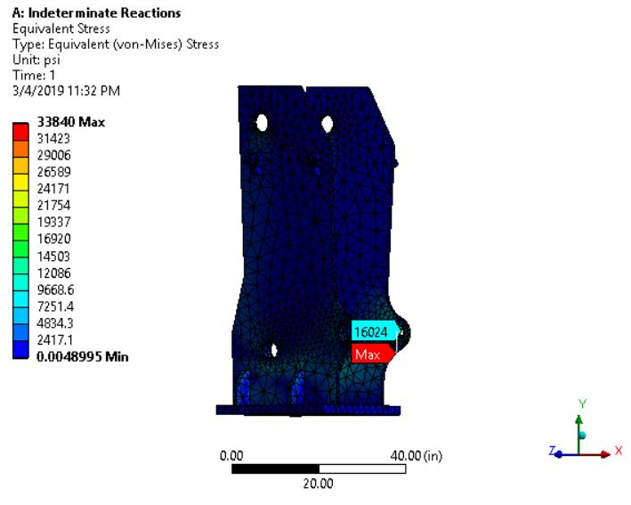
Figure 3. 11: Frame FEA result.

3.4.3 Upper Linkage analysis:
The upper linkage is a two-force member which was facing a normal stress due to the forces that acting a long its natural x-axis. There should be more attention for the tear out stress that was expected to cause a failure more than the normal stress due to the higher load might tear out the holes. To perform FE analysis of upper linkage, forces and boundary conditions were applied as shown in Figure 23. Linkage was free to displace in the z-axis, so the displacements were applied at points A and B and force of 113,000 lbf was applied at C and D as shown in Figure 3.12.

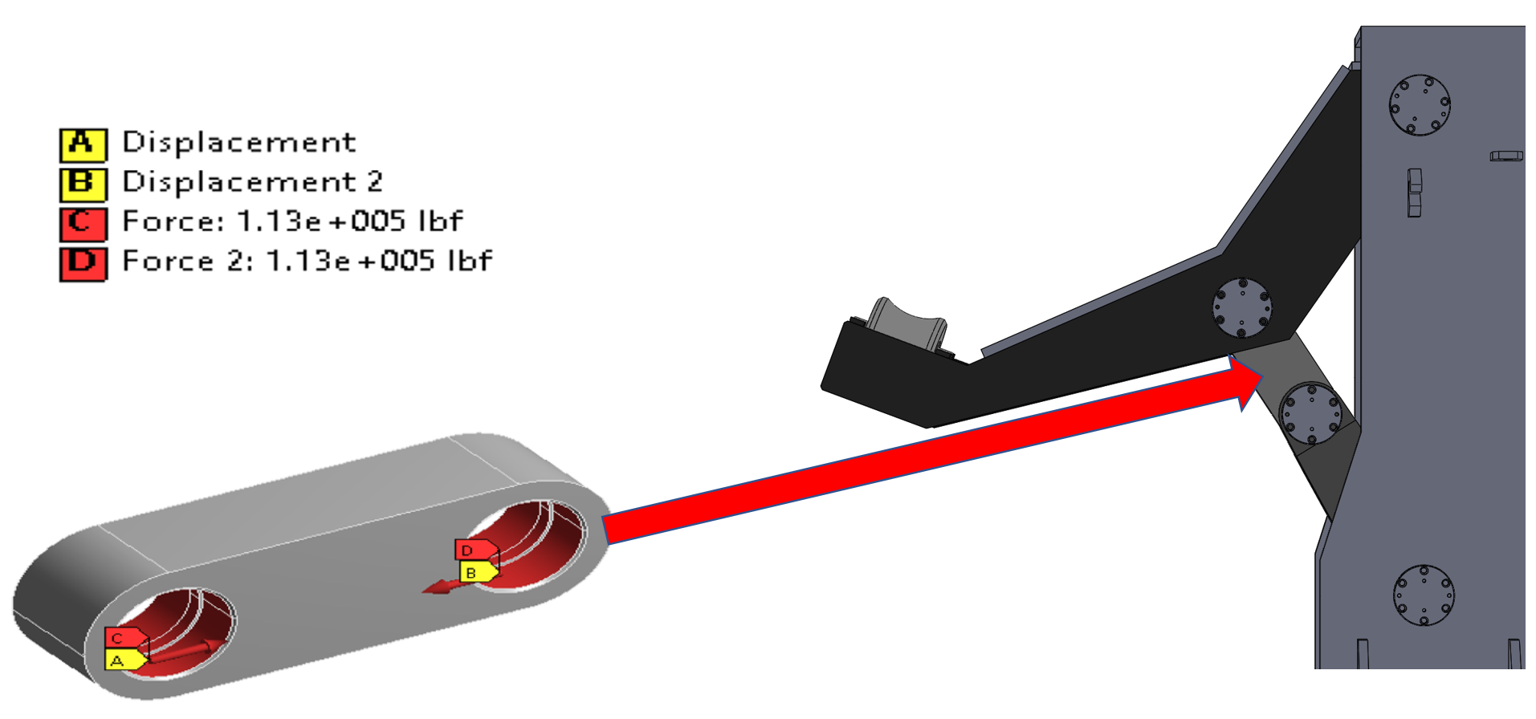
Figure 3. 12: Loads & boundary conditions setup.
The obtained result is shown in the Figure 3.13. The maximum value of equivalent stress in the upper linkage was very safe and found to be 4196 psi.

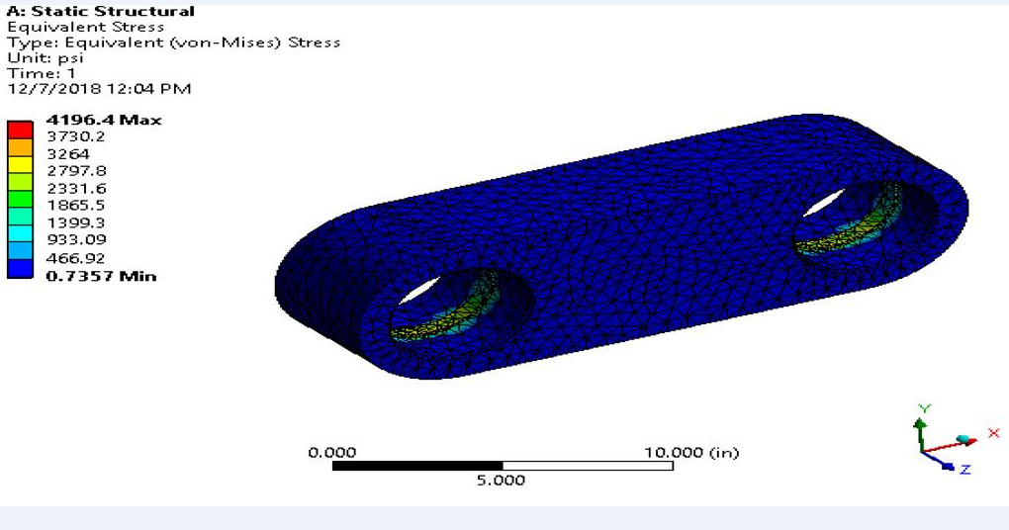
Figure 3. 13: Upper linkage FEA result.

3.4.4 Roller’s Shaft:
Forces and boundary conditions for shaft analysis are shown in Figure 3.14. Shaft was fixed at points A, B and D, and a force of 33376 lbf was applied at point C which is 6” away from point A as shown in Figure 3.14.

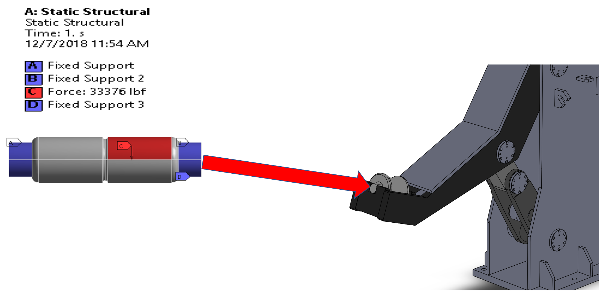
Figure 3. 14: boundary conditions setup.
Due to the stress concentration in the middle of the shaft, the stress value was very higher than the expected. In the Figure 3.15. The maximum value of stress in the shaft was found to be 30696 psi.

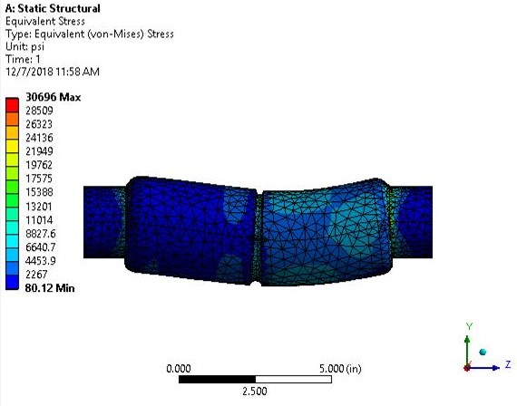
Figure 3. 15: Roller’s shaft FEA result.

3.5 Results Summary:
Table 3.1 summarized the obtained results for each component. The allowable stresses were also included in the table just to make it easier for comparison between the values.

Table 3. 1: Summarized the Stress results.
S.No. | Parts | Stress Result (psi) | Allowable stress (psi) | Allowable Shear (psi) | Allowable Bearing (psi)
1 | Arm | 14568 | 16,666 | 9616.282 | 20832.5
2 | Frame | 16024 | 16,666 | 9616.282 | 20832.5
3 | Upper Linkage | 4196 | 16,666 | 9616.282 | 20832.5
4 | Roller's Shaft | 30696 | 21,000 | 12117 | 26250
5 | Pins | 8470 | 21,000 | 12117 | 26250

CHAPTER-4
DESIGN MODIFICATIONS

4.1 Design Description
The new outboard bearing support was analyzed with the proper weight and compared with the old design. The comparable results of the two design were completed to verify the new one can withstand higher load. The new design consists of plain roller, rotating arm, upper and lower linkage, and the frame. The existing on in the other hand, has only roller bearing and rotating arm with the frame as one solid part. It can be notable that the motion type in the arm was developed from swings in a lateral to oscillatory motion which decreased the chance of risk to happened. The opportunity of the existing deign to swings into the operators of the equipment is higher which contradicts the osha regulation for machinery operations. basically, the purpose of setting the outboard bearing was to support the strip tension that exerted by the metal coil when the coiling up process occurs. In figure 4.1 shows an animated picture of the new deign while it is in the loading and unloading position, with a clearance distance between the coil and the arm in the unloading position of about 7”.

4.2 Model Creation
The solid model of the design was created by using SolidWorks to develop the 3D model to be plugged it into FEA software. Moreover, the 2D drawing detailed with all the dimensions was completed. The arm of the design swings inside itself and that motion controlled by the two linkages which need to be ensured that the linkages would never reach the dead point in order not to lose the design mobility. More details of the 2D drawing can be seen in Appendix ()
4.2.1 Kinematics Analysis:
The design considered to be 4 bar mechanism. The analysis

4.1 Standardized Plate Size
Plate size was standardized in order to consider the manufacturability constraints and provide the design solution which makes it feasible to build the parts. In the previous section, while designing the parts plate size was obtained from the design calculations and that size may not be the standard which is available in the market. The standard plate sizes are nominal sizes which means it is an increment of 0.25in. To meet these requirements, all plate size was standardized by changing the designed thickness to the next standard thickness to ensure that durability of the components is not compromised. For example, the designed plate thickness was changed from 1.8 in to 2.00 in which is the next standard plate size available. The same plate size can’t be designed with 1.75 as it may not meet the structural durability requirements as this standard thickness is less than the designed thickness. If the designed thickness is already a standard thickness, then no changes were made to it. For example, arm cover plate thickness was obtained as 1 in from the design calculations and therefore, no changes were made to this plate.

4.2 Optimized Design
In the first iteration of the design, some of the components were meeting the design specifications and few parts didn’t meet the durability requirements. It is important to ensure that all components satisfies the design criterion i.e. stresses in the parts should be less than the design allowable stress. In the first design iteration it was observed that the shaft and rotating arm didn’t meet the design criterion. Therefore, it was important for the group to look at this and fix the issue to ensure that all parts satisfy the design requirements. Following sub-section shows the details of action taken in order to fix the failure parts:
4.2.1 Roller’s Shaft
In the first design iteration, it was observed that shaft had high stresses in the middle due to U-shaped groove and at the end fillet locations. This issue was discussed with the client and a solution to this issue was recommended by the group as removing the U-shaped groove to avoid high stress at the center. There was no significant compromise was made in terms of increase in the mass as the U-groove size was much smaller compared to the shaft size. Other high stress region was the end fillets, which was fixed by increasing the fillet radius to ensure that the stresses and displacement are within allowable limits. Figure 4.1 and Figure 4.2 show the boundary condition and stress results in the shaft after the design modifications. For the boundary condition, the two shoulders of the shaft were set as fixed and the force was remoted to be about 6.5” away from the right shoulder.
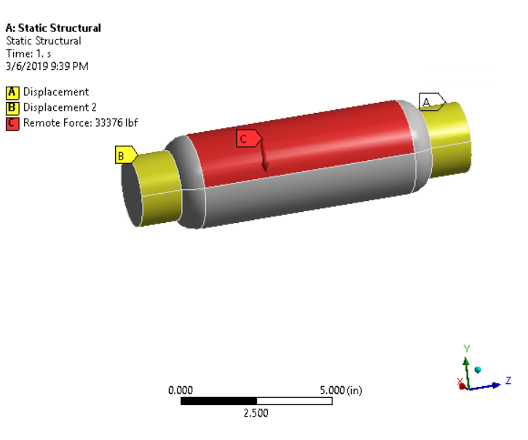
Figure 4.1: Displacement - Shaft (After design modifications)
The result of the modified shaft was obtained to be 19,723 psi for the max stress. Highest stress would occurs in the fillet shoulder that located in the right side of the shaft due to the highest bending moment.
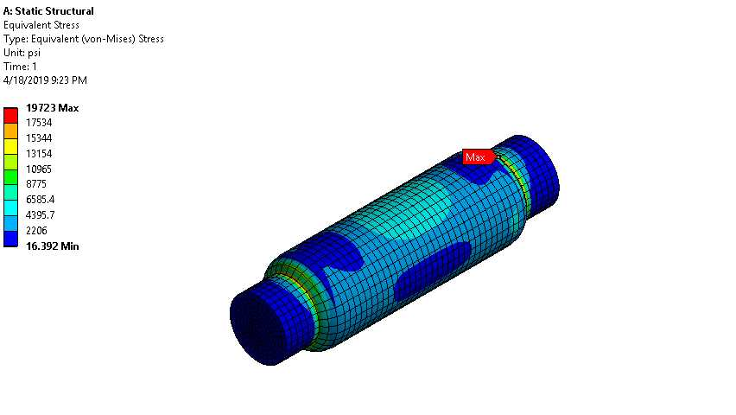
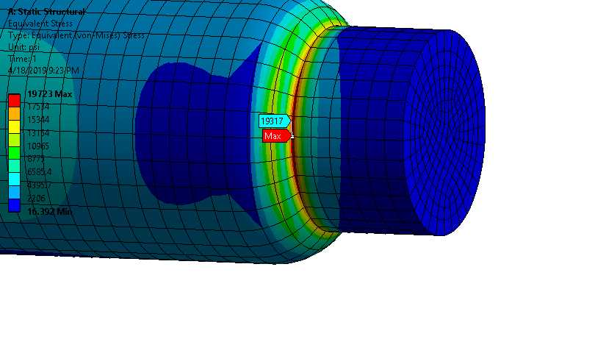
Figure 4.2: von Mises Stress - Shaft (After design modifications)
The shaft was built from steel 1018 which has a yield strength of 64,000 psi. Hand calculation was also reapplied to the redesigned model that has a new stress concentration factor for the shoulder fillet. The following equations were used to calculate the max stress of the shaft which was obtained to be about 20,000 psi. It was shown that the result very much identical to the FEA result and they were lower than the allowable stress. The created free body diagram of the shaft can be seen in figure 4.3 with all the detailed dimensions.

4.2.2 Rotating Arm
The arm has plates at the top and there was a space between the two plates which causes high stress concentration region and therefore the design of arm didn’t meet the design criterion. This issue was fixed by making the two plates as one single part and therefore section modulus at the weaker section got increased. Additionally, the high stress concentration due to the sharp corners of the plate at the bending region was eliminated by making a bending radius in the new design which did not exceed the allowable limited bending radius. Modified design gives a smooth flow of stress and also the stresses are made within allowable by doing such modification. Figure 4.3 and Figure 4.4 show the boundary conditions and stress results respectively in the arm after the design modifications. The pins reactions were set as remote displacement that free to rotate about the z axis and the load was applied to the shaft.
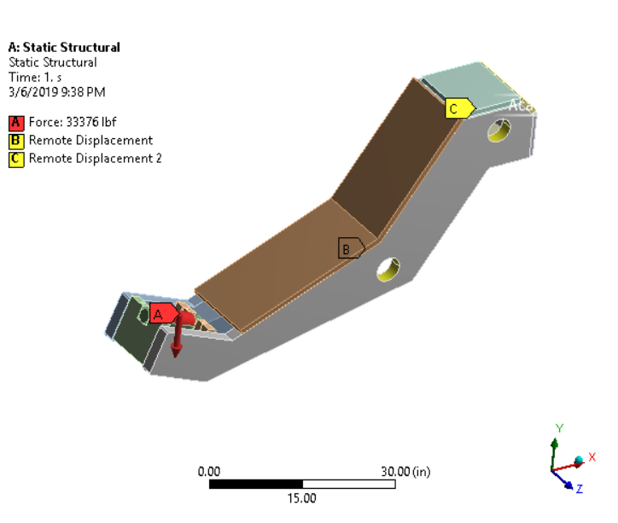
Figure 4.3: Boundary Conditions - Arm (After design modifications)
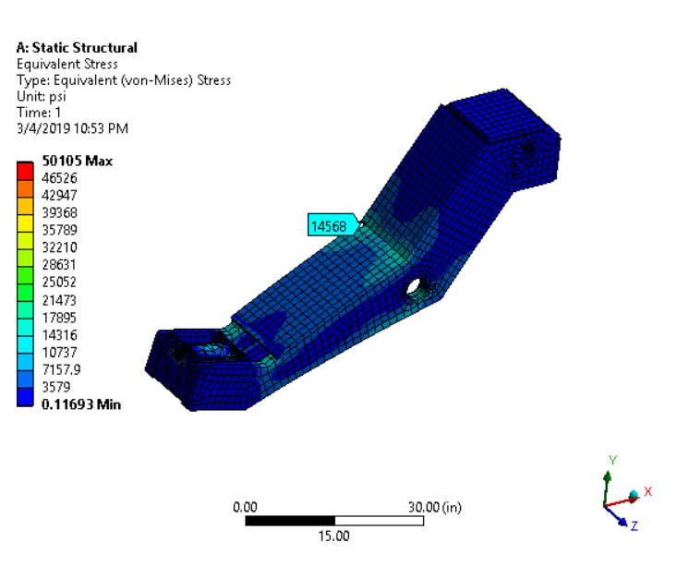
Figure 4.3: von Mises Stress - Arm (After design modifications)
The bending allowance which is the length of the natural axis in the bend zone. To validate the machining process of the created bending in the plate, the allowable bending was calculated by using the following equations. The allowable bending was obtained to be 11.5” and that exceed the plate was bended with a radius of 4”.

4.2.3 Frame’s Base and bolts deign:
There was a failure in the frame’s base due to the small size of its thickness. To ensure that the base can resist the applied load, the part was brought to Ansys. The base was beefed up with 1” extra to make the thickness of the frame being 2”. Also, the bolts of the foundation were designed based on the maximum load reaction acting in the right front bolts hole. It was so obvious to say that when the load acting in the design, the bolts in the front would be in compression while the other in the back would be in tension. The hand calculations of the frame base stress were done by following equation 4 which was provided from SES. The stress result after the design alteration was obtained to be about 7,573 psi which is very safe in term of failure.

The bolts were built from 1203 steel. The maximum reaction load acting on the bolts was found to be 48,888 Ibf. The obtained result from Ansys can be seen in figure 4.4.
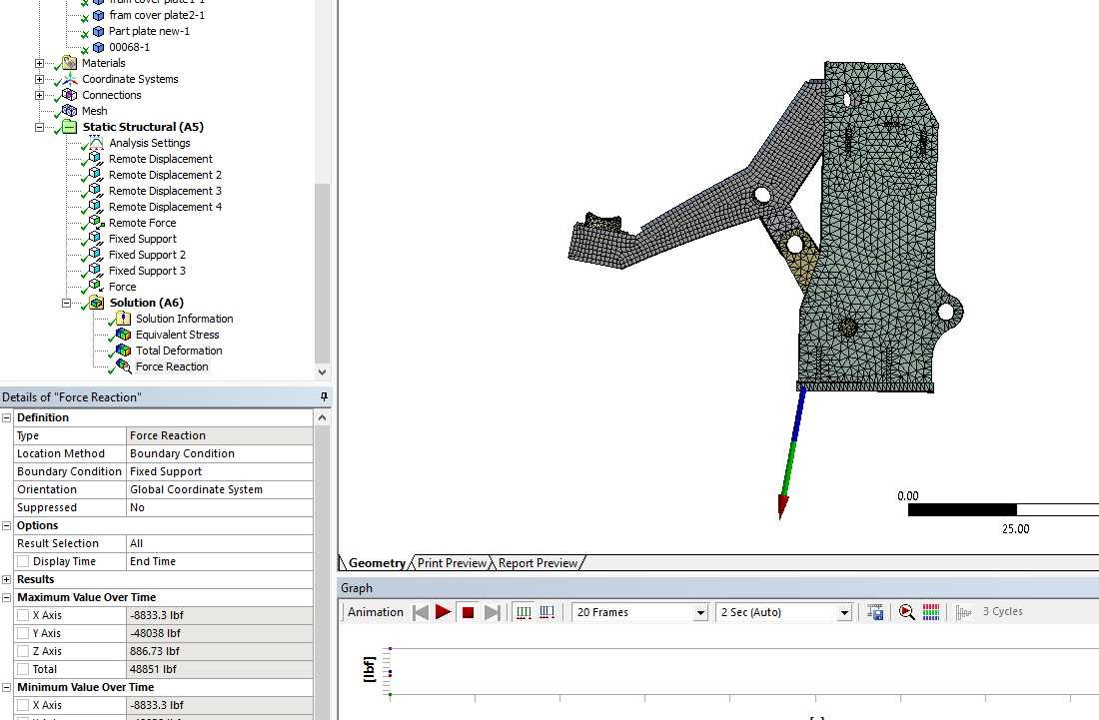
After the load was found, the

In process to be finished

4.3 comparing
Compare the results of the old design and the one which we created. The force acting on it was 27000 lbf just change it to our force which is 33,376 lbf and apply it to the equations in the pictures. We need to compare the results between the two designs just to see which one withstand more weight. For example, the plain bearing has a stress value of 6 psi and the roller bearing which they have right now has a stress value of 8 psi, so our design can be more capable. We want to go through the entire designs because this chapter indicates the final result. (you will find the equations in PDF file attached in the email).

4.4 Motion Analysis
If you can do a little Kinematics analysis of how the arm will move (the mechanism of the arm) some analysis will prove that the arm will move in the direction that shows in the video that I’m attaching in the email.

4.5 meet the characteristics
Customer Need
3-D Software Package
Imperial dimensions
1500 maximum input pressure
Nominal imperial sizes of plates
Withstand heavy weight
Mandrel support arm clearance
Budget
High load
Bearing Support
Safety

Describe each one of these and how the design meets the customer needs

4.6 Safety
How the design is safety (The new design swings down inside of itself and does not take up a larger footprint or space envelope than the widest part of the machine. Also find some safety features in the design and include it)

Appendix:

Shaft calculations
Moment of inertia: 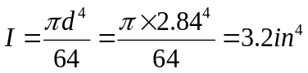
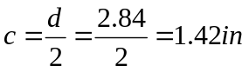
Bending stress: 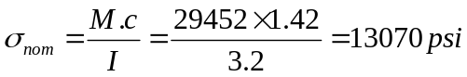
Stress concentration factor, corresponding to r/d=0.05 and D/d=1.1 => k_{b} = 2.25
(Very High stress)
This is a possible failure point in the shaft.

Pin calculations
Normal stress: 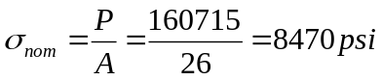(Safe)
Bearing Stress: 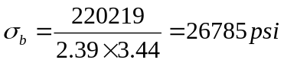(Very high stress) [Bearing area is calculated using solidworks.
This is a possible failure location as allowable bearing stress is 20832 psi.
The minimum area to avoid failure should be:
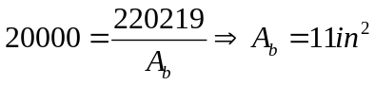

Roller Bearing calculations
D=8.66 inches

A=πD=π.(8.7)=27.3 in²
Therefore, the roller distance = (6/27.3) x100% = 22% of the area is rotating
Bearing stress = P/A_{b}
A_{b} = 3.97 x 7.86 = 31.2 in²
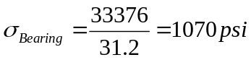
The cross sectional area = 26.5 in²
Normal stress = 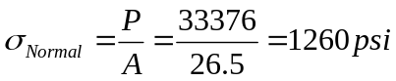

Arm calculations
B_{y}

33376 lbf
A_{y}
34 inches 19.5 inches

Moment equilibrium at B:

- 33376(34+19.5)-A_{y}(19.5)=0
- A_{y} = 91467 lbf
Force equilibrium:
- -33376+A_{y}-B_{y}=0
- -33376+91467 = B_{y}
- B_{y} =58091 lbf
Highest bending moment in the arm:
M = 33376(34) = 1134784lb-in
Cross sectional area at point A = 52.42 in²
I_{z} =1056.82 in⁴
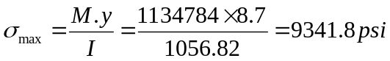 (Safe)
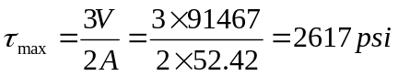 (Safe)
Using steel A572G50 => S_{y} =50,000 psi
Allowable stress:
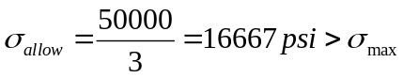

Lower linkage calculations
F_{c} = 180395lbf
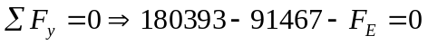
F_{E} =88926 lbf
Resultant force at each pin:
At pin B: 91467/cos(35⁰) =111661 lbf
At pin E: 88926/cos(35⁰) = 108560 lbf
At pin C: 180393/cos(35⁰) = 220219 lbf

Upper linkage calculations

The normal stress acting on the linkage:
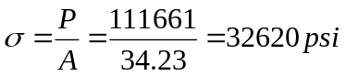
Tear out stress:
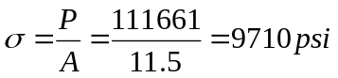
The above results are for the upper linkage in the rising position.
